CSS BOX MODEL
Every HTML element is a box.
If you don’t think in boxes, layouts will break.

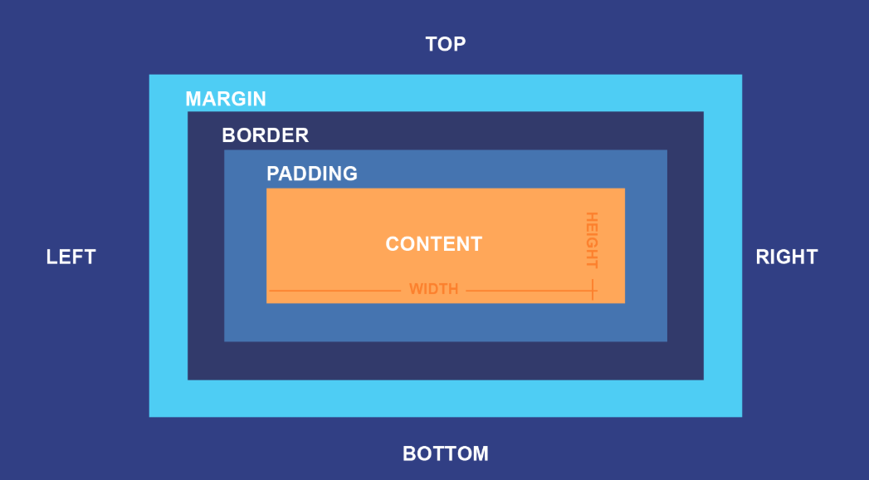

Width & Height (VERY COMMON TRAP)
.box {
width: 200px;
height: 100px;
}
Important
width applies to content only (by default)
Padding & border are added on top

Why Layout Breaks When Padding Is Added?

❌ Default behavior (content-box)
.box {
width: 200px;
padding: 20px;
}
Actual rendered width:
200 (content)+ 20 + 20 (padding)
= 240px ❌
Element becomes bigger than expected
Layout breaks

box-sizing (LAYOUT SAVER)

✅ Use this ALWAYS
* {
box-sizing: border-box;
}
Now:
.box {
width: 200px;
padding: 20px;
}
Rendered width:
200px TOTAL ✅
Interview GOLD
“box-sizing: border-box keeps layout predictable.”

Margin (Outer Space)
.card {
margin: 16px;
}
Creates space between elements
Vertical margins can collapse
Use margin for spacing between components, not inside.

Padding (Inner Space)
.card {
padding: 16px;
}
Space between content & border
Increases clickable area (UX win)

Borders
.card {
border: 1px solid #ccc;
}
Adds visual boundary
Counts in size (unless border-box)

Max-width (RESPONSIVE GOLD)
.container {
max-width: 1200px;
margin: auto;
}
Why this matters:
Prevents very wide text
Improves readability
Essential for responsive layouts
Senior rule
Use max-width, not fixed width, for containers.

Overflow
.box {
overflow: hidden;
}
Values:
visible (default)
hidden
scroll
auto
Used when:
Content exceeds container
Modals
Cards
Tables

COLORS, TEXT & FONTS (MUST)
This is about readability, not decoration.

CSS Colors
Ways to define color:
color: black;
color: #333;
color: rgb(0,0,0);
Use hex or rgb for consistency.

Backgrounds
background: #f5f5f5 url(bg.png) no-repeat center;
Shorthand can include:
color
image
repeat
position
Avoid writing 5 separate background properties unless needed.

Text Basics
p {
font-size: 16px;
line-height: 1.5;
color: #333;
}

Key rules:
16px ≈ standard base
Line-height improves readability
Avoid very light text on white

Font Size Units
Unit | Use
px | Fixed size
rem | Scales with root
em | Relative to parent
Senior rule
Use rem for scalable, accessible text.
Example:
body { font-size: 16px; }
h1 { font-size: 2rem; }

Fonts
body {
font-family: Arial, sans-serif;
}
Guidelines:
Always include fallback
Avoid too many fonts
Prefer system fonts for performance

